Student ID:
Brief Summary:
Database security has increasingly become an important part of cybersecurity. There are 6 out of 10 top cybersecurity risks directly related to database. Therefore, we developed a blockchain-based database system which outperformed other database on access control capabilities and blockchain validation and used prototype system to test it. [48]

Video Plan:
Time | Content  (very short summary of what this part of the video is) | Script  (the dialog that will be recorded to communicate content) | Visual  (visual elements represented on the screen) | Justification  (refer to audience, and choice of content and visuals)
18 | Introduction of database security & integrity by demonstrating an SQL injection attack. | Have you ever thought about how exactly an attacker can hack your website and make irreversible damages?  Here’s an example of simple SQL injection.  Assume that I’m not a user of this vulnerable website, but by using this script, I can easily obtain all the user information stored in the database.  Yes, even without a password! | Demonstrating a simple SQL injection.  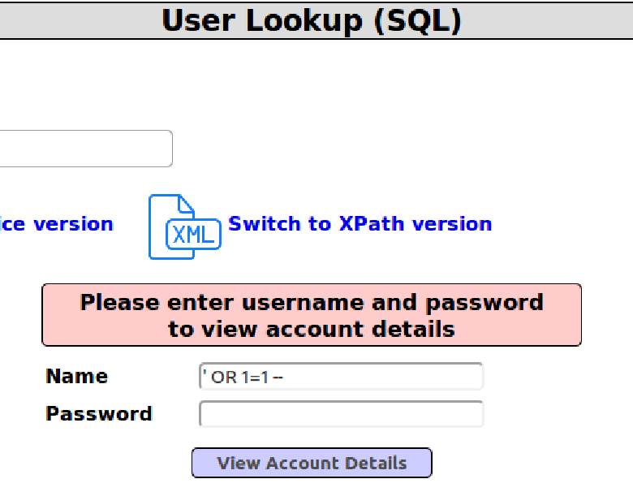 | This is the introduction part that should be attractive. The audience have some knowledge about technology, but they are not expert on cybersecurity. This fact gives me inspiration that I can show the audience how an actual attack works.  This content will release 2 signals to our audience:  1) It is important to protect their database.  2) I am professional in cybersecurity, so they can trust me to introduce my product.
12 | Explain that the previous action is legal. | I hope you are not too scared.  What I did is just purely based on a legal test website. Nothing hurts.  But what if an actual attack happens to your database?  Can you be completely sure that your database is safe? | 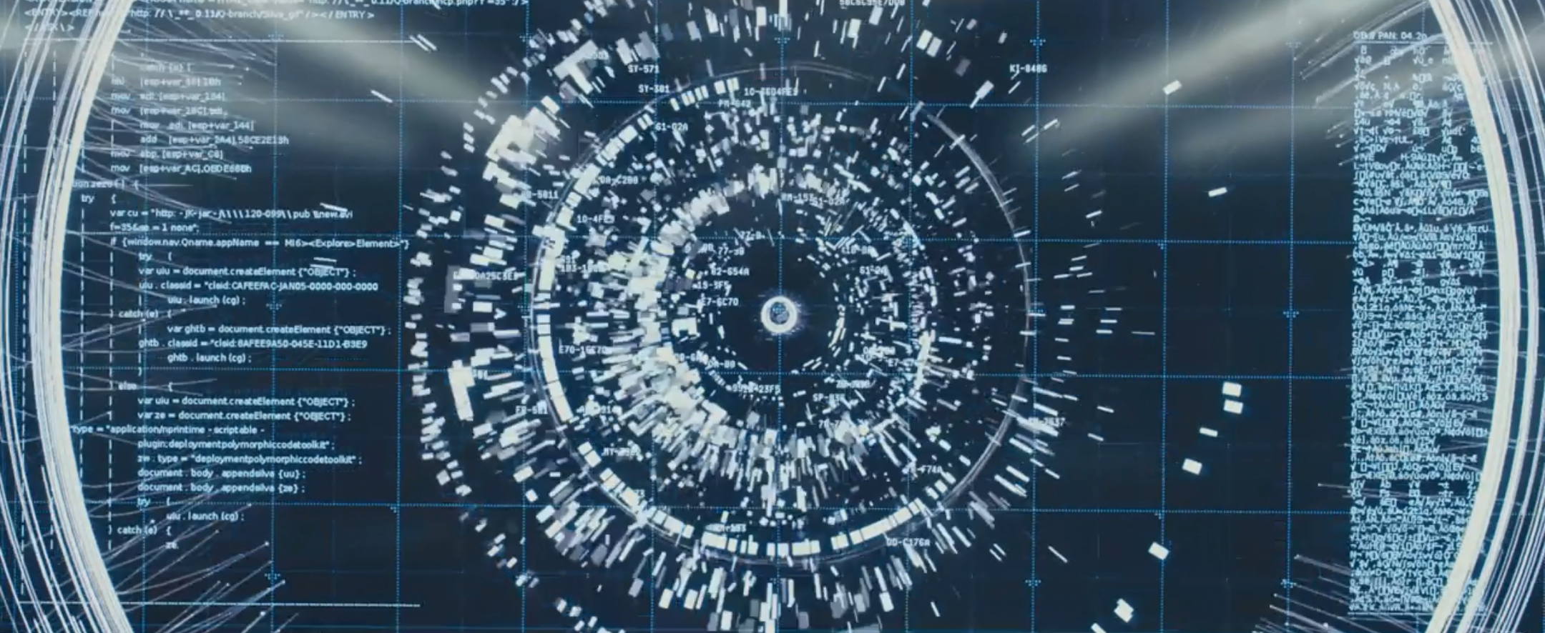 | This is a transition between the storytelling and the importance. I must declare that the attack I just demonstrate is legal, otherwise there will be extra concern from the audience, which we absolutely should avoid.  The visual content is from 007: Skyfall, which I use to attract the audience.
10 | The importance and shortage of nowadays database security | The fact is, if you look at the top 10 application security risks, there are 6 related to the database. This is why we’re going to introduce you our blockchain-based encrypted database. | OWASP TOP 10 Application Security Risks  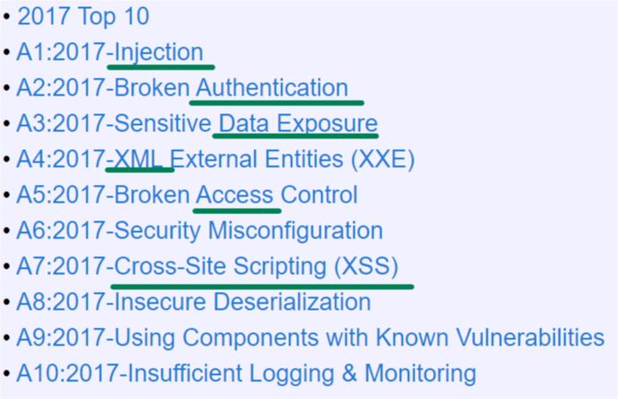 | Many companies, even those big ones, do not care enough about database security. So, it is important to state again that there are many vulnerabilities in database due to the nature of it.  The visual content is from OWASP – the most trustworthy website in cybersecurity area. It will make the audience believe that we are professional, and the issue of database security is urgent.  We can introduce the audience to our advanced database by this transition.
14 | Outperform: Access control capabilities | Comparing to the existing database systems, our access control capabilities will bring us a proxy-free architecture, which will allow users to access the data remotely and securely and validate the data provided by data owner. | Key point on PPT.  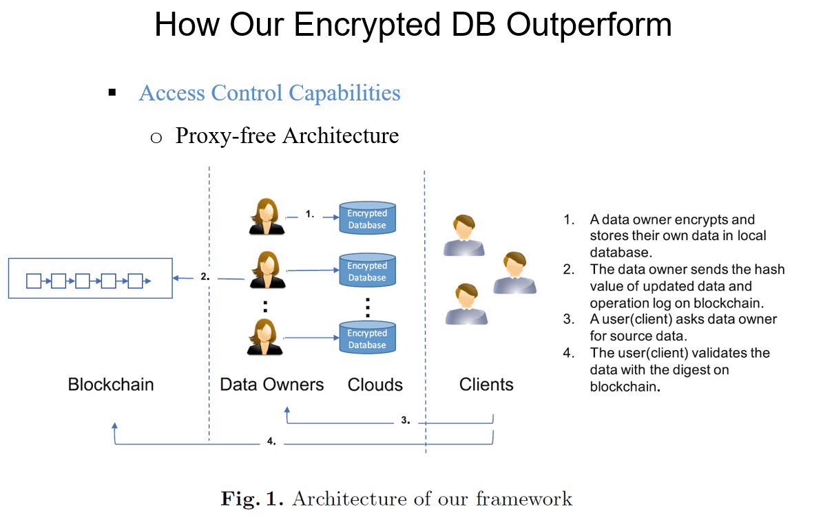 | This is the paper-related part in our pitch. This part will be technical since we need to show the audience that we do have a reliable and excellent product. We will introduce the advance in access control capabilities.
14 | Outperform: Blockchain Validation | Blockchain Validation will implement a Tampering Protection Mechanism, which will make modification of user information still feasible but harder. The basic database system that we use is BigchainDB, an open-source decentralized database system. | 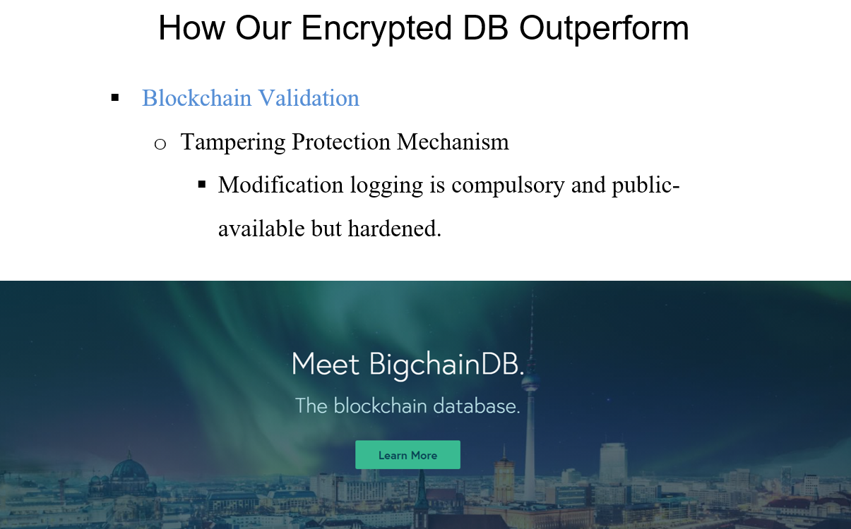 | The other outperform things is blockchain-based database. We need to introduce the audience what our database is based on, and the advantages of it.
16 | Outperform: performance | We outperform the existing system mainly on 3 parts:  a more secure MySQL performance,  a faster BigchainDB,  and a more secure attribute-based encryption.  Thus, our product will bring you a well-protected up to date blockchain-based encrypted database. | 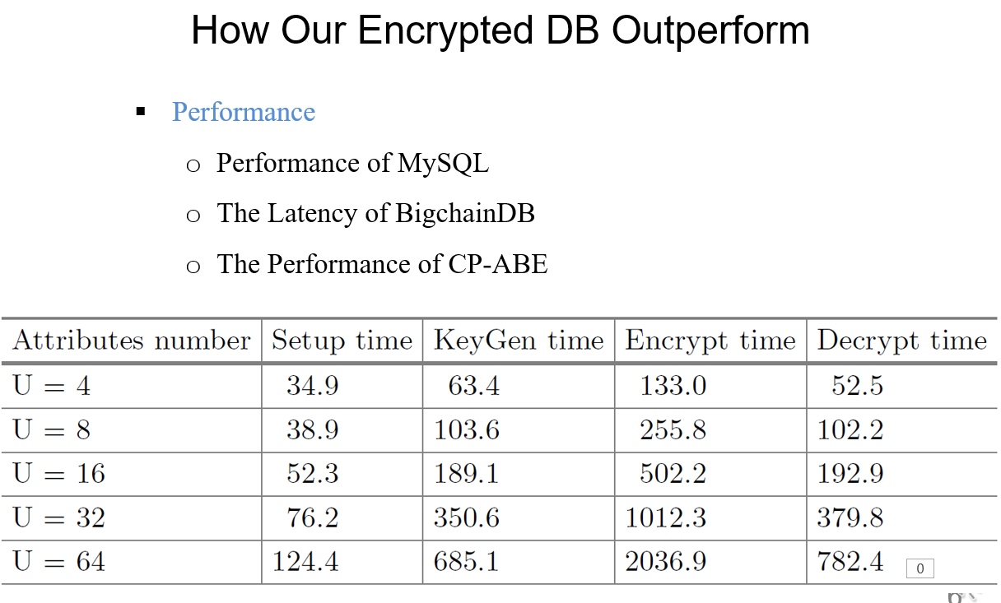 | This is the evidence that our system really outperforms the existing database. We need to show them our test results to gain their trusts.
6 | Thank the audience | If you’re interested in our research, please use the following contact information.  Thanks for watching our video. | 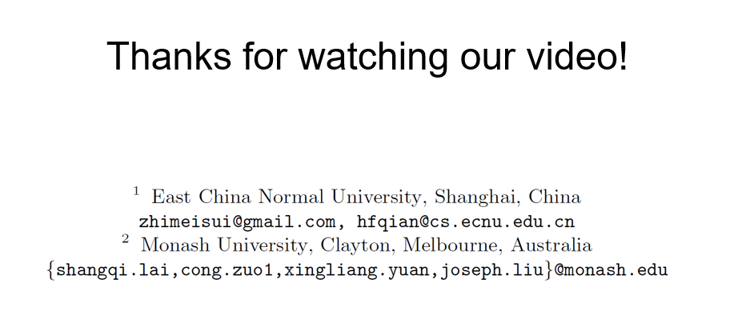 | We want the audience to contact us after this pitch, so we should better leave the clear contact information in the end.

